**Home Page:**

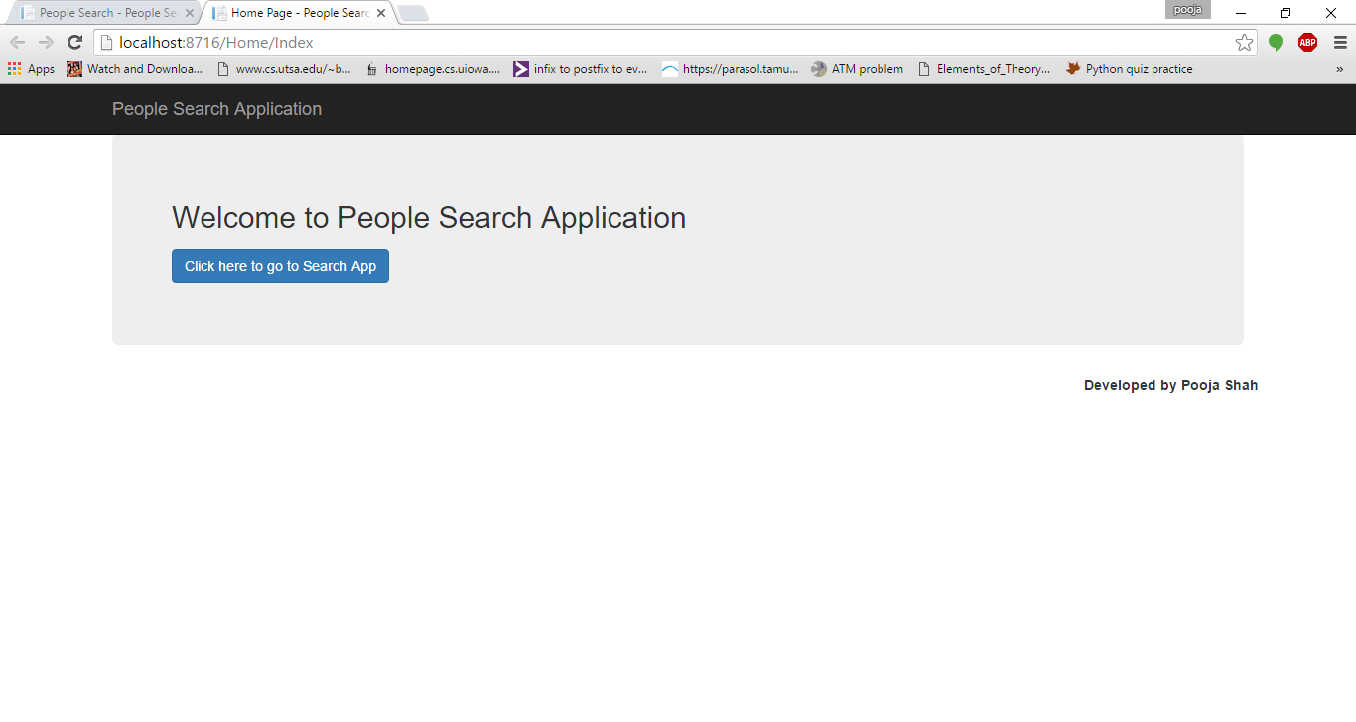

**After clicking on button on Home Page, this page appears (person search application):**

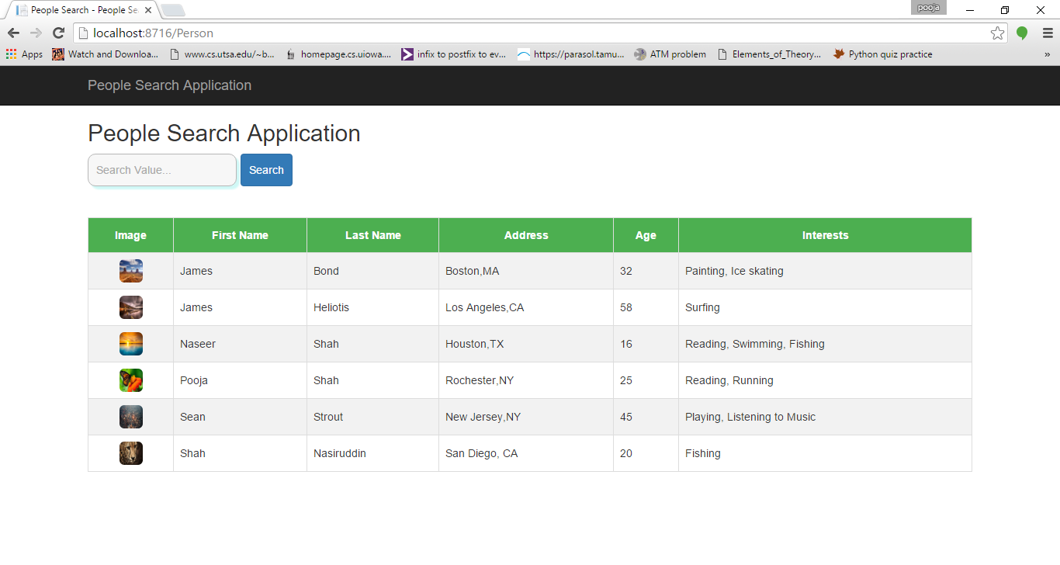

**After entering search value and pressing search button:**

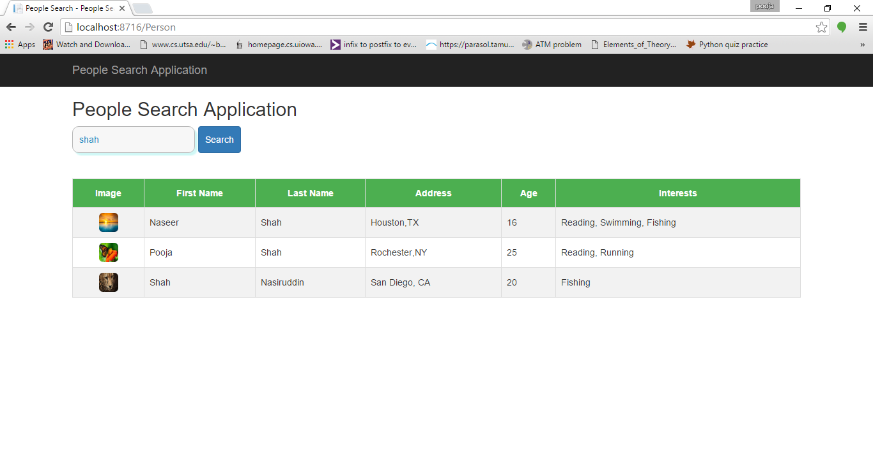

**If invalid characters except “alphabetic characters, ‘(apostrophe), .(full stop)” are entered, a message is displayed on the page saying characters entered are invalid and there is no change in other parts of the page:**

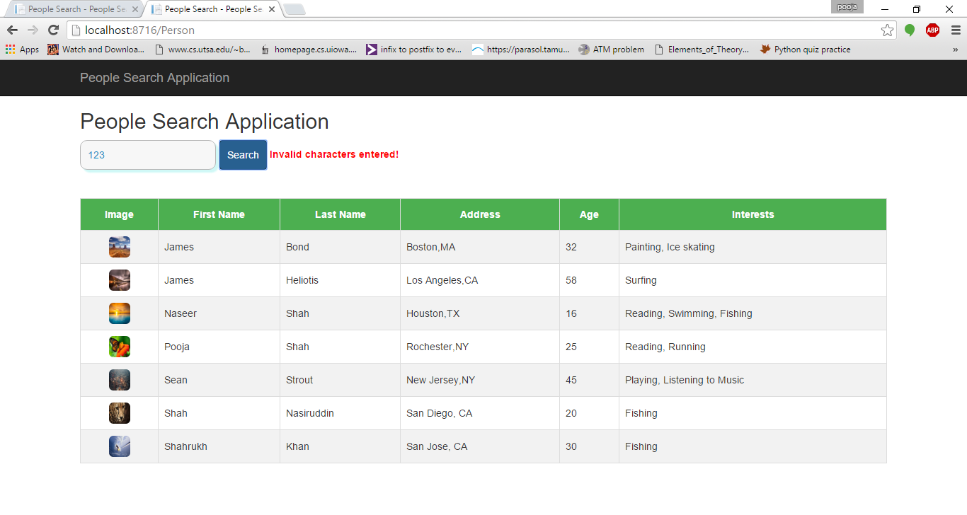

**When no records are found, a message is displayed saying “No records found”:**

